ASSISTANCE SYSTEM FOR PEOPLE WITH VISUAL IMPAIRMENTS USING IoT

***A Project report submitted in partial fulfillment of the requirements for the award of the degree of***

**BACHELOR OF TECHNOLOGY**

**IN INFORMATION TECHNOLOGY**

**Submitted by**

|  |  |
| --- | --- |
| K.Vishnu Vardhini | (320126511081) |
| B.Saketh | (320126511064) |
| S.Kavitha | (320126511104) |
| K.Akash | (320126511078) |

**Under the guidance of Mr.M.V Kishore Assistant Professor**



**DEPARTMENT OF INFORMATION TECHNOLOGY**

ANIL NEERUKONDA INSTITUTE OF TECHNOLOGY AND SCIENCES (UGC AUTONOMOUS)

(*Permanently Affiliated to AU, Approved by AICTE and Accredited by NBA & NAAC with ‘A’ Grade*) Sangivalasa, Bheemili Mandal, Visakhapatnam dist.(AP)

2023-2024

**DEPARTMENT OF INFORMATION TECHNOLOGY**

**ANIL NEERUKONDA INSTITUTE OF TECHNOLOGY AND SCIENCES**

**(UGC AUTONOMOUS)**

**(*Affiliated to AU, Approved by AICTE and Accredited by NBA & NAAC with ‘A’ Grade*)**

**Sangivalasa, Bheemili Mandal, Visakhapatnam dist.(A.P)**



**CERTIFICATE**

This is to certify that the project report entitled “**ASSISTANCE SYSTEM FOR PEOPLE WITH VISUAL IMPAIRMENTS USING IoT”** submitted by **K.Vishnu Vardhini(320126511081),B.Saketh(320126511064),S.Kavitha(320126511104),K.Akash(32**

**0126511078)** in partial fulfillment of the requirements for the award of the degree of **Bachelor of Technology** in **Information Technology**of Anil Neerukonda Institute of technology and sciences (A), Visakhapatnam is a record of bonafide work carried out under my guidance and supervision.

**Project Guide Head of the Department**

**Mr.M.V KISHORE Dr.M.REKHA SUNDARI**

Assistant Professor Professor

Department of IT Department of IT

ANITS ANITS

# DECLARATION

We, **K.Vishnu Vardhini(320126511081), B. Saketh(320126511064),S. Kavitha(320126511104),**

**K. Akash(320126511078)** of final semester B.Tech., in the department of Information Technology from ANITS, Visakhapatnam, hereby declare that the project work entitled **“ASSISTANCE SYSTEM FOR PEOPLE WITH VISUAL IMPAIRMENTS USING IoT”** carried out by us and

submitted in partial fulfillment of the requirements for the award of **Bachelor of Technology in Information Technology**, under Anil Neerukonda Institute of Technology & Sciences(A) during the academic year 2023-2024 and has not been submitted to any other university for the award of any kind of degree.

|  |  |
| --- | --- |
| K.Vishnu Vardhini | 320126511081 |
| B.Saketh | 320126511064 |
| S.Kavitha | 320126511104 |
| K.Akash | 320126511078 |

# ACKNOWLEDGEMENT

We would like to express our deep gratitude to our project guide **Mr.M.V KISHORE,** Department of Information Technology, ANITS, for his guidance, unsurpassed knowledge, and immense encouragement. We are grateful to **Dr.M.REKHA SUNDARI**, Head of the Department of Information Technology, for providing us with the required facilities for the completion of the project work.

We are very much thankful to the **Principal and Management, ANITS, Sangivalasa,** for their encouragement and cooperation in carrying out this work.

We thank all the **teaching faculty and non-teaching staff** of the Department of IT, whose suggestions during reviews helped us in the accomplishment of our project.

We would like to thank our parents, friends, and classmates for their encouragement throughout our project period. At last, but not the least, we thank everyone for supporting us directly or indirectly in completing this project successfully.

**PROJECT STUDENTS**

**K.Vishnu Vardhini (320126511081),**

**B.Saketh (320126511064),**

**S.Kavitha (320126511104)**

**K.Akash (320126511078),**

# CONTENTS

**Chapter Name Pg No.**

**ABSTRACT i**

LIST OF FIGURES ii

LIST OF ABBRIVATIONS iii

1. INTRODUCTION
   1. Introduction 2
   2. Motivation 2
   3. Problem Statement 3
   4. Objective of the project 3
   5. Limitations of project
      1. Bulkiness 4
      2. Battery life 4
      3. Can’t detect fake currency notes 4
   6. Organization of Documentation 4
2. LITERATURE SURVEY
   1. Introduction 7
   2. Existing System 7
   3. Disadvantages of Existing System
      1. Limited Detection Range 8
      2. Dependency on Specific Environments 9
      3. Hardware Complexity 9
      4. Lack of customization 9
      5. Performance variability 9
   4. Proposed System
      1. Reading Images 10
      2. Image Preprocessing 11
      3. Feature Extraction 11
      4. Data for Testing 11
      5. Algorithm for matching 11
      6. Dataset details 12
      7. Model Training
         1. KNN 13
         2. ORB 14
   5. Conclusion 16
3. ANALYSIS
   1. Introduction 18
   2. Software Requirement Specification
      1. Introduction 18
      2. User Requirements 22
      3. Hardware Requirements 23
      4. Software Requirements 24
   3. Conclusion 26
4. DESIGN
   1. Introduction 28
   2. UML Diagrams
      1. Use Case Diagram 28
      2. Class Diagram 29
      3. Sequence Diagram 30
      4. Activity Diagram 31
      5. Architecture Diagram 33
      6. Data flow Diagram 34
   3. Module design and organization 36
   4. Conclusion 37
5. IMPLEMENTATION AND RESULTS
   1. Introduction 39
   2. Explanation of key functions
      1. Currency note detection code 39
      2. Face recognition code 42
      3. Smart Stick Code 45
   3. Method of Implementation 46
      1. Output Screens 48
      2. Result Analysis 49
   4. Conclusion 53
6. TESTING AND VALIDATION
   1. Introduction 54
   2. Design of Test Cases and Scenarios 56
   3. Validation 57
   4. Conclusion 58
7. CONCLUSION 60
8. REFERENCES 62
9. PAPER PUBLICATION WITH PLAGIARISM REPORT 66

# ABSTRACT

The "Assistance system for people with visual impairments using IoT" is a groundbreaking assistive technology designed to revolutionize the daily experiences of visually impaired individuals. By integrating state-of-the-art technology into wearable devices such as smart glasses and a smart stick capable of detecting obstacles, this innovative kit offers a comprehensive solution to enhance independence and confidence.

One of its most remarkable features is its ability to detect currency and provide audible feedback regarding its denomination. This functionality, powered by artificial intelligence and computer vision, empowers visually impaired individuals to effortlessly handle money in their day-to-day lives, offering a level of autonomy previously unimaginable.

In this article, we will explore the extraordinary capabilities and advantages of the Assistance system for visually impaired individuals using IoT. From its advanced detection of obstacles to its seamless currency recognition, we will delve into how this transformative technology is reshaping the way visually impaired individuals interact with currency, providing them with newfound freedom and security.

**i**

# LIST OF FIGURES

|  |  |  |
| --- | --- | --- |
| **Fig No.** | **Topic Name** | **Page No.** |
| 1 | Proposed system | 10 |
| 2 | Currency notes dataset | 12 |
| 3 | BRIEF | 15 |
| 4 | Use case diagram for smart specs | 28 |
| 5 | Use case diagram for smart Stick | 29 |
| 6 | Class diagram | 30 |
| 7 | Sequence Diagram | 31 |
| 8 | Activity Diagram | 32 |
| 9 | Architecture Diagram of smart stick | 33 |
| 10 | Architecture Diagram of smart specs | 34 |
| 11 | Data Flow Diagram of smart stick | 35 |
| 12 | Data Flow Diagram of smart specs | 35 |
| 13  14  15  16  17  18  19  20 | Putty for getting IP address of Raspberry Pi To Select the Raspberry Pi os  Raspberry pi os Arduino IDE  Currency note detection plot Face detection plot  Smart Stick Smart Spects  **ii** | 48  48  49  49  51  51  52  52 |

**LIST OF ABBREVIATIONS**

|  |  |
| --- | --- |
| IoT | Internet of things |
| SVM | Support Vector Machine |
| SIFT | Scale-invariant feature |
| ORB | Oriented FAST and Rotated BRIEF |
| AI | Artificial Intelligence |
| ML | Machine Learning |
| DL | Deep Learning |
| HOG | Histogram of Oriented Gradients |
| OpenCV | Open-Source Computer Vision |
| RAM | Random Access Memory |
| GB | Giga Bytes |
| UML | Unified Modeling Language |
| IDE | Integrated Development Environment |

**iii**























             





























 































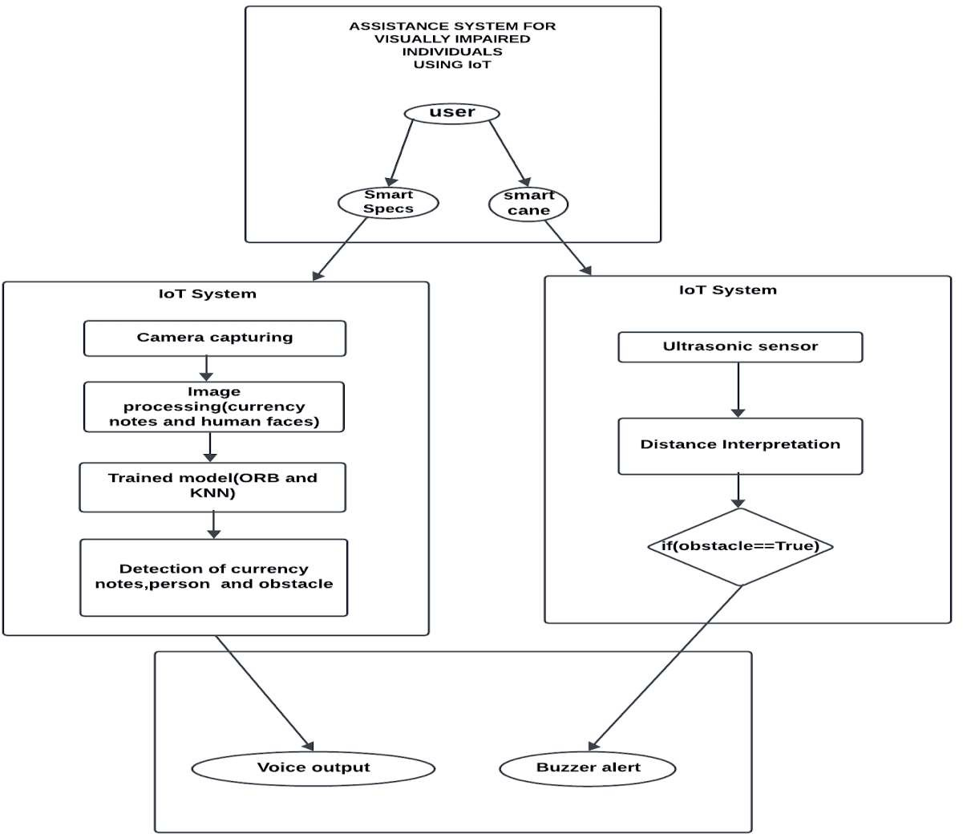























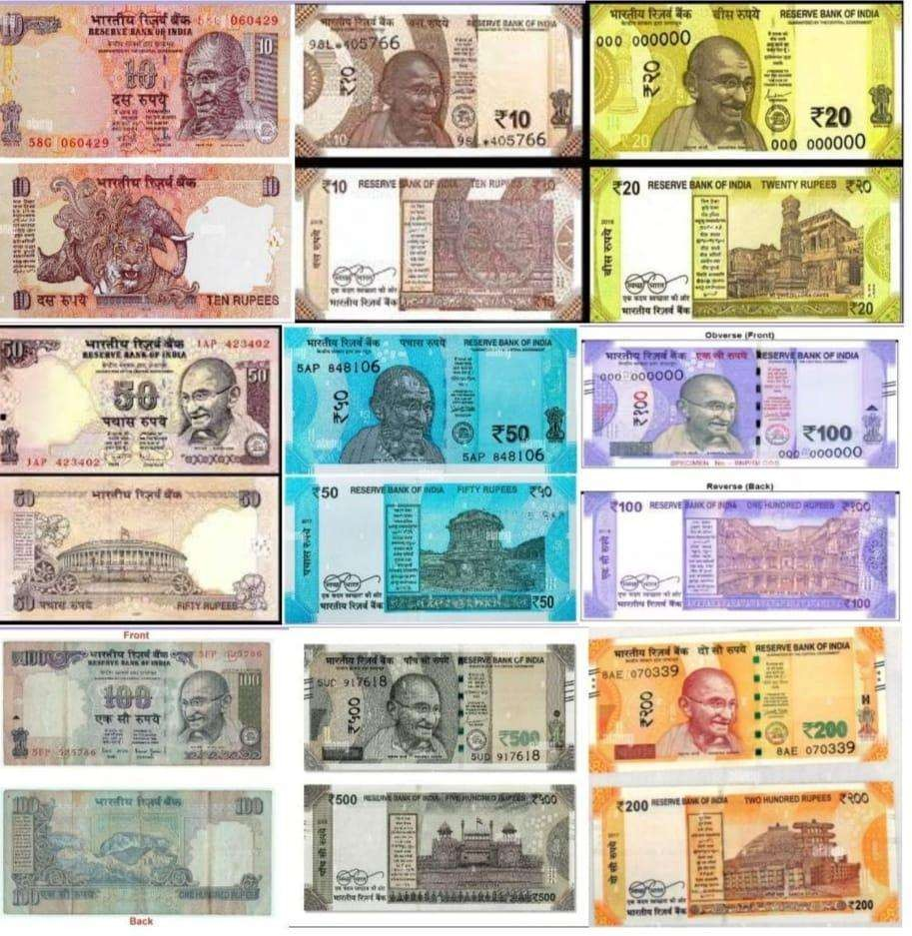





















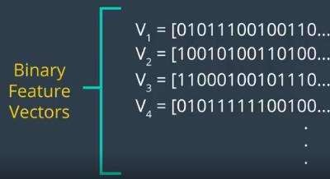

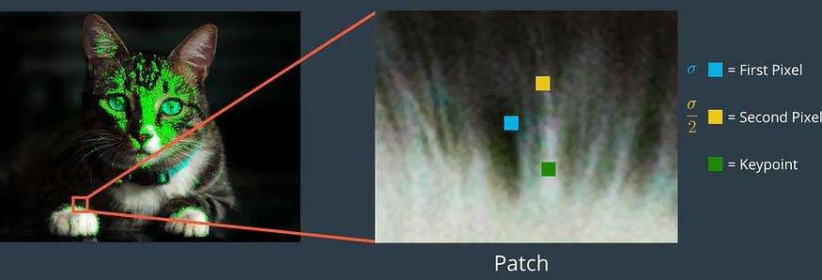



















































       













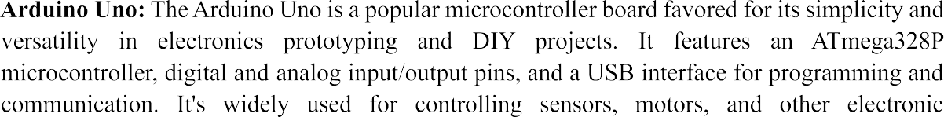

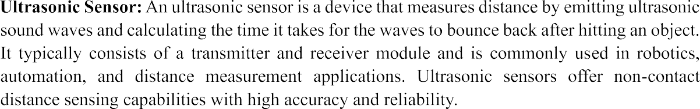

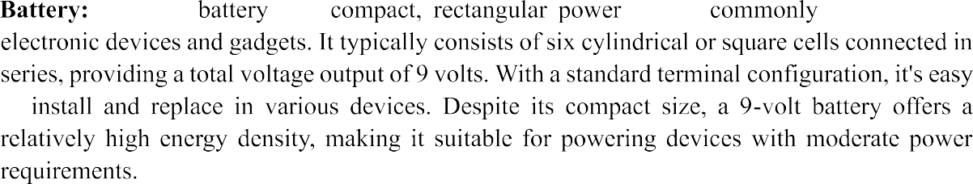



































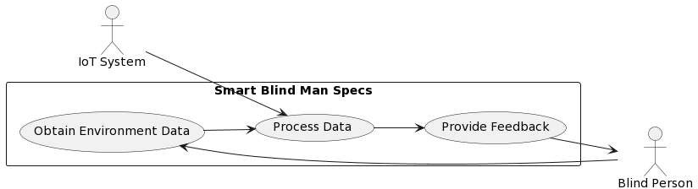

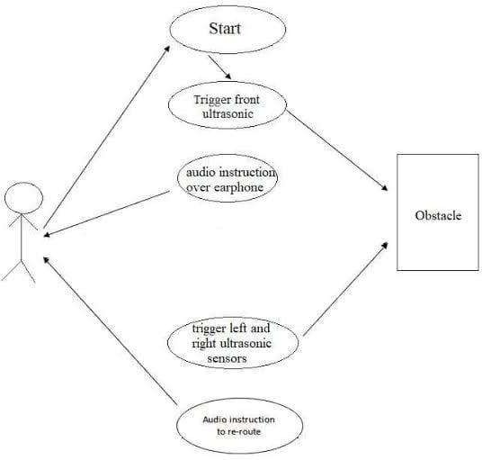









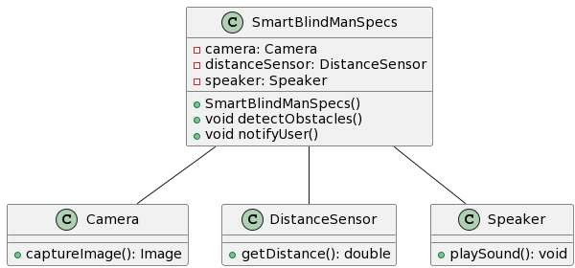











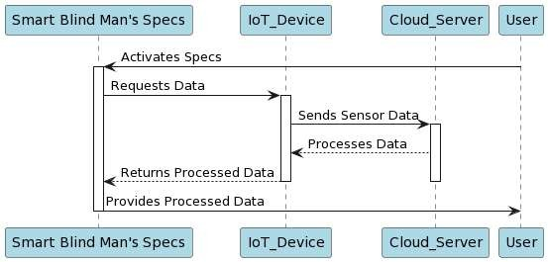













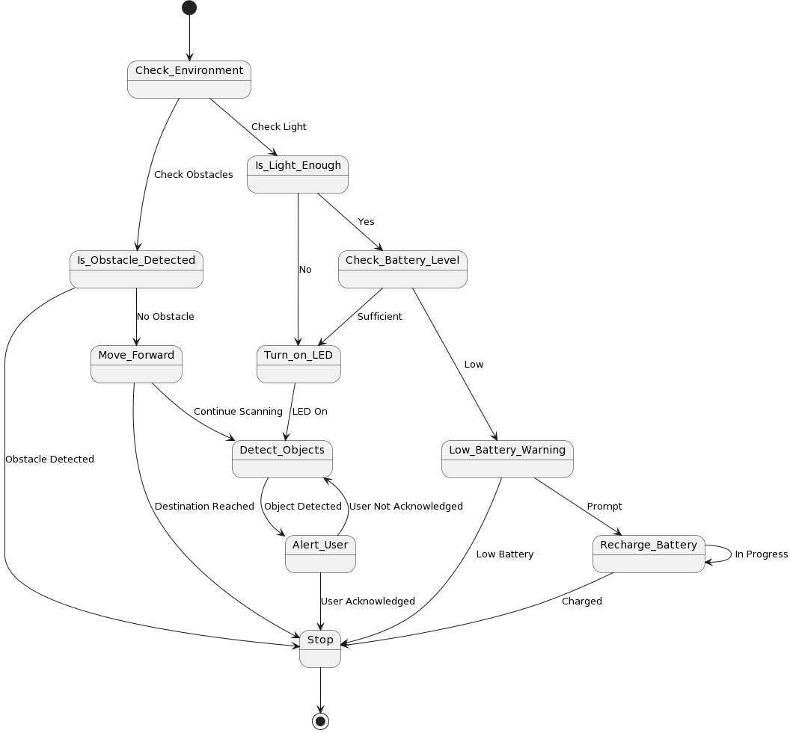











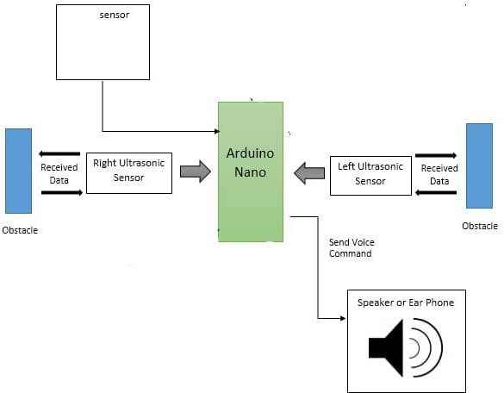





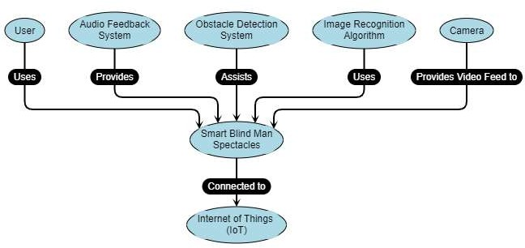







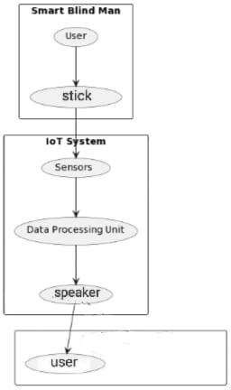

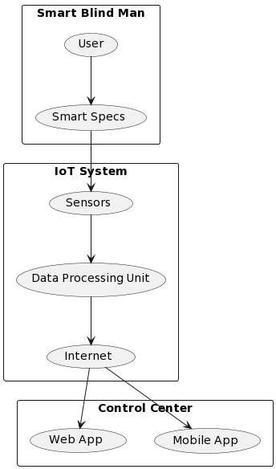











































































































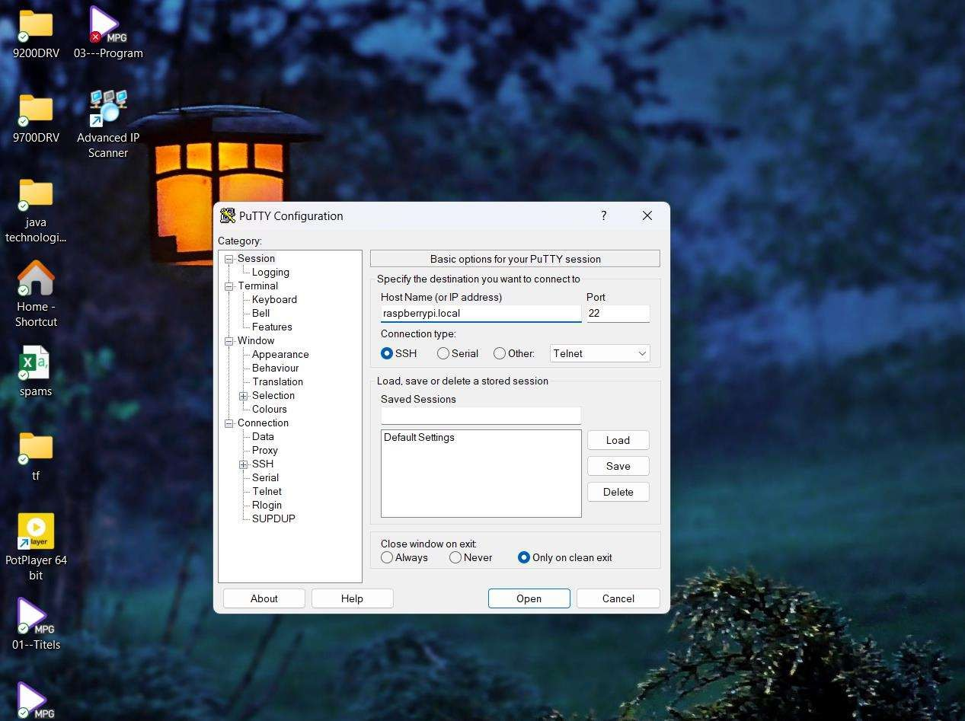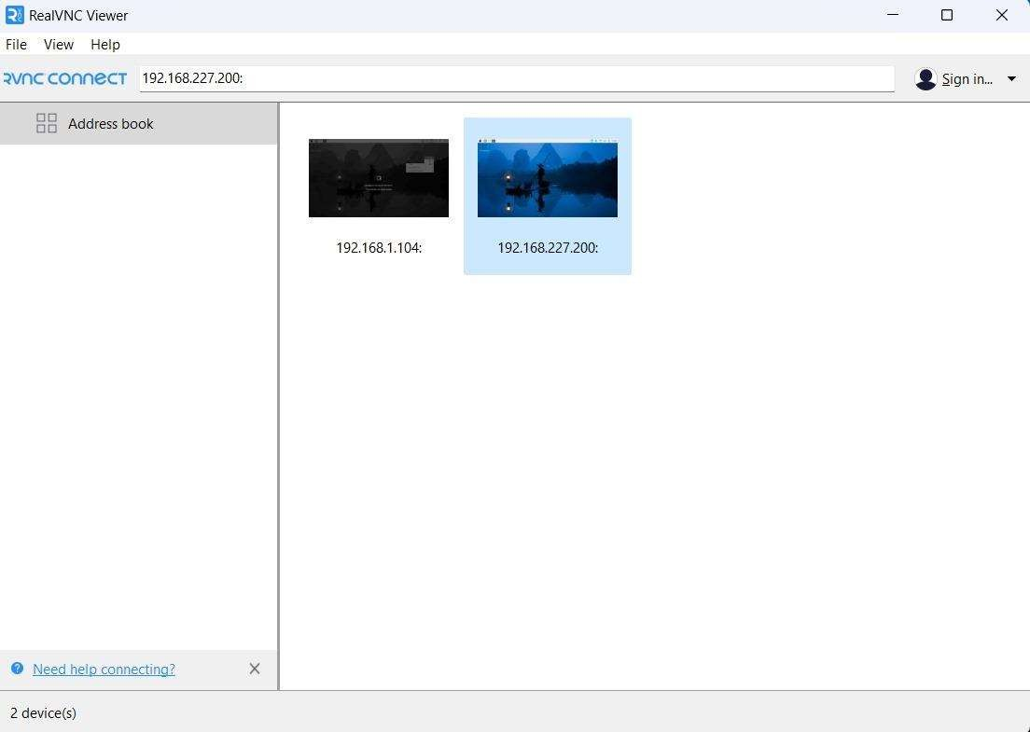

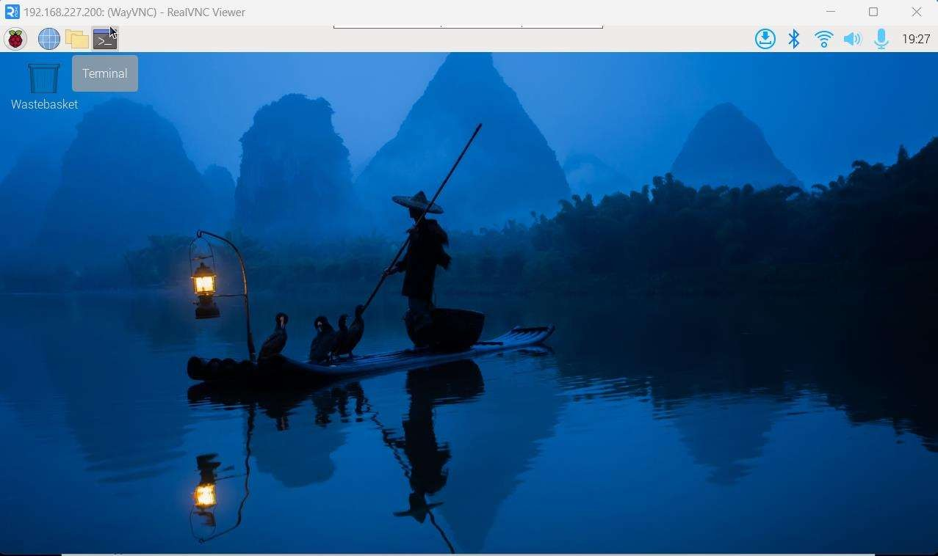



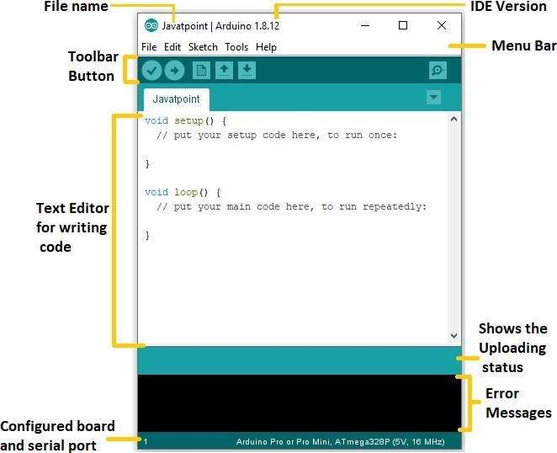











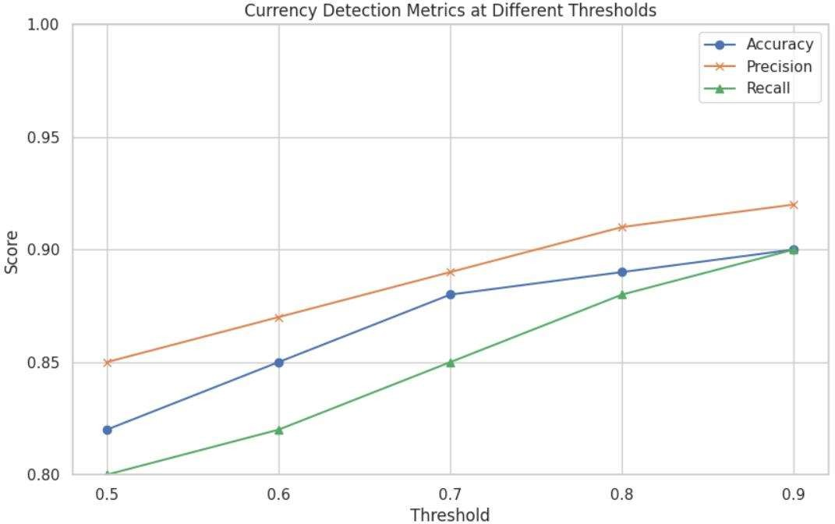

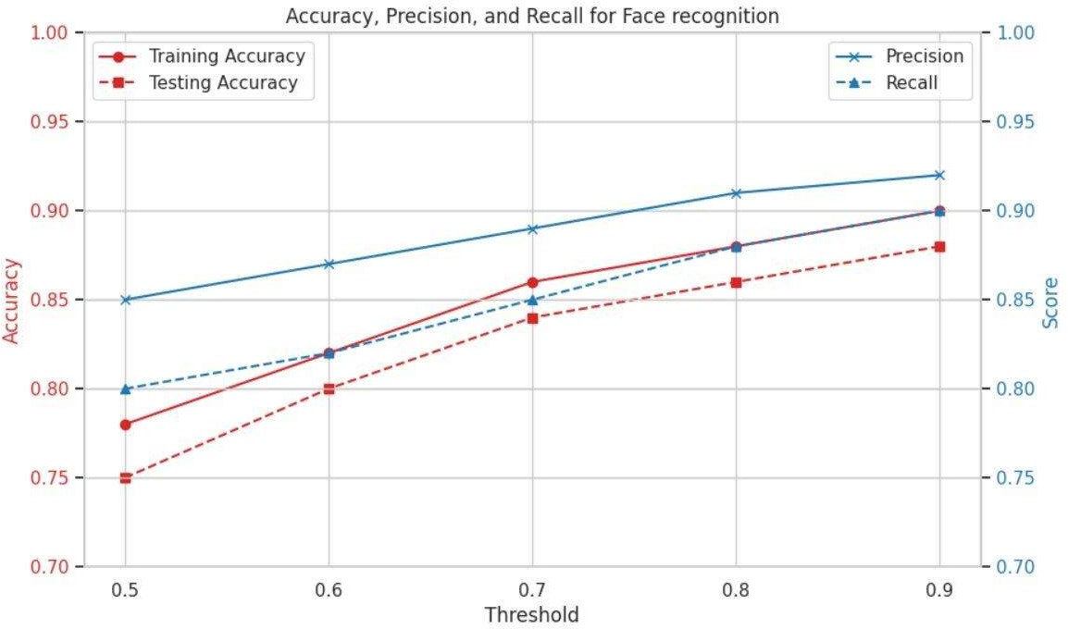

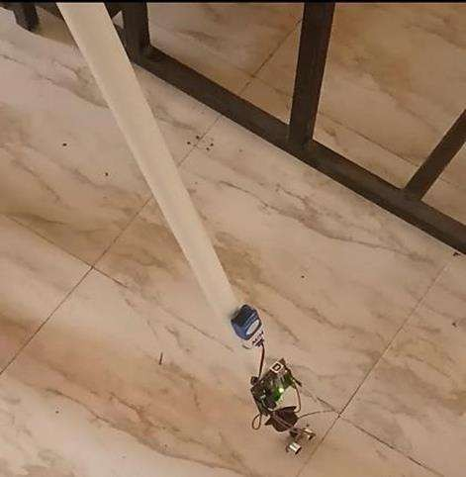



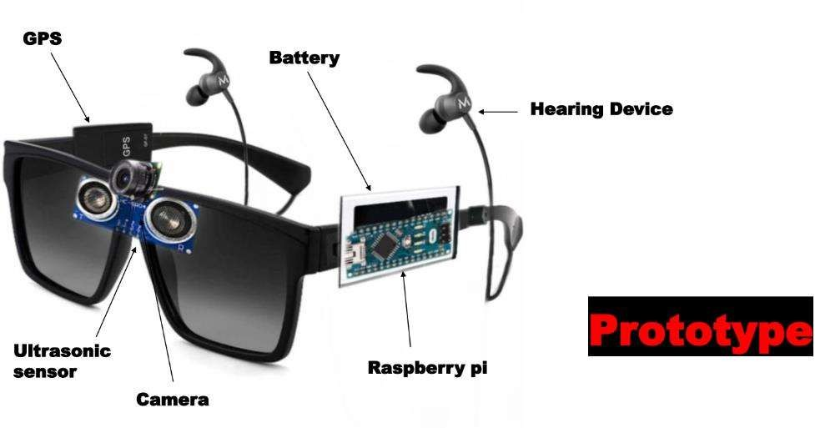

































































 

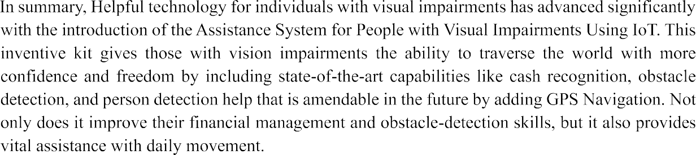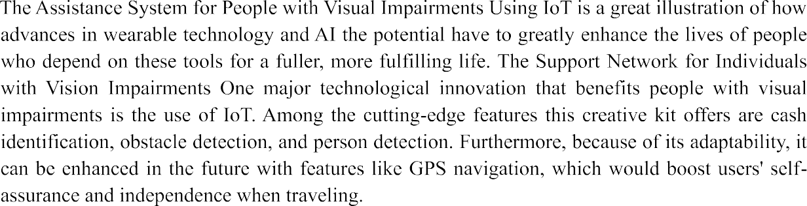



# CHAPTER 8 REFERENCES

61

# REFERENCES

[1]. R. Radhika, P.G. Pai, S. Rakshitha and R. Srinath “Implementation of Smart Stick for Obstacle Detection and Navigation.” International Journal of Latest Research in Engineering and Technology, vol. 2, number 5, pp. 45-50, 2016.<http://www.ijlret.com/Papers/Vol-2-issue-> 5/8-B2016247.pdf.

[2]. G. Gayathri, M. Vishnu Priya, R. Nandhini and M. Banupriya “Smart Walking Stick for Visually Impaired.” International Journal of Engineering and Computer Science, vol.3, number 3, pp. 4057- 4061, 2014.https:/[/www.ijec](http://www.ijecs.in/index.php/ijecs/article/view/151)s[.in/index.php/ijecs/article/view/151.](http://www.ijecs.in/index.php/ijecs/article/view/151)

[3]. A. Jose, G. George, M.R. Nair, M. J. Shilpa and M. B. Mathai “Voice-Enabled Smart Walking DICKENSIAN JOURNAL VOLUME 22, ISSUE 4, 2022 ISSN NO: 0012-2440 PAGE

NO: 910 Stick for Visually Impaired.” International Journal of Advanced Research in Electrical, ElectronicsandInstrumentationEngineering,vol.5pp.8085,2016.https:/[/www.rese](http://www.researchgate.net/pu)a[rchgate.net/pu](http://www.researchgate.net/pu) blication/361842044_Development_of_e-stick_for_blind_persons_using_IoT.

[4]. M.H. Mahmud, R. Saha, and S. Islam “Smart Walking Stick – An Electronic Approach to Assist Visually Disabled Persons.”International Journal of Scientific and Engineering Research, vol. 4, number 10,pp.111-114,2013.https:/[/ww](http://www.ijser.org/researchpaper/Smart-walking-stick-)w[.ijser.org/researchpaper/Smart-walking-stick-](http://www.ijser.org/researchpaper/Smart-walking-stick-) an-electronic-approach-to-assist-visually-disabled-persons.pdf

[5]. S. Singh, S. Choudhury, K. Vishal and C. V. Jawahar, Currency Recognition on Mobile Phones, 22nd International Conference on Pattern Recognition (ICPR), Sweden, (24 August 2014),pp:26612666,IEEE.[https://www.researchgate.net/publication/279803436_Currency_Rec](https://www.researchgate.net/publication/279803436_Currency_Recognition_on_Mobile_Phones) [ognition_on_Mobile_Phones.](https://www.researchgate.net/publication/279803436_Currency_Recognition_on_Mobile_Phones)

[6]. Z. Solymár, A. Stubendek, M. Radványi,and K. Karacs, "Banknote recognition for visually impaired,"inCircuitTheory.https:/[/www.rese](http://www.researchgate.net/publication/287998433_Currency_Re)a[rchgate.net/publication/287998433_Currency_Re](http://www.researchgate.net/publication/287998433_Currency_Re) cognition_System_for_Visually_Impaired_Egyptian_Banknote_as_a_Study_Case.

[7]. Semary, Gad, A. F. ”Currency Recognition System for Visually Impaired: Egyptian Banknote as a Study Case,” In the 5th International IEEE Conference on Information & Communication Technology and Accessibility (ICTA), pp. 1-6,2015.

[8]. Ahmed Yousry. , Mohamed Taha and Mazen M.Selim.” Currency Recognition System for Blind People using ORB Algorithm”.Article in International Arab Journal of Information Technology,January2018.[https://www.researchgate.net/publication/329487411_Currency_Rec](https://www.researchgate.net/publication/329487411_Currency_Recognition_System_for_Blind_people_using_ORB_Algorithm) [ognition_System_for_Blind_people_using_ORB_Algorithm](https://www.researchgate.net/publication/329487411_Currency_Recognition_System_for_Blind_people_using_ORB_Algorithm).

62

[9].[https://www.researchgate.net/publication/348370440_Pakistani_Currency_Recognition_to](https://www.researchgate.net/publication/348370440_Pakistani_Currency_Recognition_to_Assist_Blind_Person_Based_on_Convolutional_Neural_Network)

[_Assist_Blind_Person_Based_on_Convolutional_Neural_Network](https://www.researchgate.net/publication/348370440_Pakistani_Currency_Recognition_to_Assist_Blind_Person_Based_on_Convolutional_Neural_Network)

[10].Snehal Saraf., Vrushali Sindhikar., Ankita Sonawane., Shamali Thakare.” Currency Recognition System for Visually Impaired”.Snehal Saraf, Information Technology, MCOERC,Maharashtra,India.https://ijariie.com/AdminUploadPdf/Currency_Recognition_Sys tem_For_Visually_Impaired_ijariie4599.pdf

[11]. Jyothi, Ch Ratna, Y. K. Sundara Krishna, and V. Srinivasa Rao. "Paper currency recognition for color images based on Artificial Neural Network." In Electrical, Electronics, and Optimization. Techniques (ICEEOT), International Conference on, pp. 3402-3406. IEEE, 2016. [12].Doush, Iyad Abu., et al. "Currency recognition using a smartphone: Comparison between color SIFT and grayscale SIFT algorithms." Journal of King Saud University-Computer and InformationSciences29.4pp.484492,2017.https://[www.researchgate.net/publication/304781790](http://www.researchgate.net/publication/304781790)

_Currency_Recognition_Using_a_Smartphone_Comparison_Between_Color_SIFT_and_Gray

_Scale_SIFT_Algorithms

[13]. Sarfraz, et al. "An intelligent paper currency recognition system." Procedia Computer Science Journal, Vol. 65, pp. 538-545, 2015.

[14]. Youn, S, Lee, C, Chulhee Lee “Efficient multi-currency classification of CIS banknotes” Elsevier Neurocomputing, Vol. 156, pp. 22-32, May 2015.

[15].Fattouh, AM Ali. "A non-parametric approach for paper currency recognition." International Journal of Computer Science and Software Engineering vol. 4, no. 5, pp. 121-125, 2015.

[16].Shweta Yadav., Mr. Zulfikar Ali Ansari., KaushikiGautam Singh.” CURRENCY DETECTION FOR VISUALLY IMPAIRED”.2020 JETIR May 2020, Volume 7, Issue

5.https:/[/www.jetir.org/papers/JETI](http://www.jetir.org/papers/JETIR2005143.pdf)R[2005143.pdf](http://www.jetir.org/papers/JETIR2005143.pdf)

[17]. Vivek Sharan., Amandeep Kaur.” Detection of Counterfeit Indian Currency Note Using Image Processing”.International Journal of Engineering and Advanced Technology(IJEAT).https:/[/www.ij](http://www.ijeat.org/wpcontent/uploads/papers/v9i1/A9972109119.pdf)e[at.org/wpcontent/uploads/papers/v9i1/A9972109119.pdf](http://www.ijeat.org/wpcontent/uploads/papers/v9i1/A9972109119.pdf) [18]. Larisa Dunai Dunai ., Mónica Chillarón Pérez .”Euro Banknote Recognition System for Blind People”.Research Center in Graphic Technology, Universitat Politècnica de València, Camino de Vera s/n, 5L,Valencia 46022, Spain; gperis@upv.es(G.P.-F.); [ilengua@degi.upv.es](mailto:ilengua@degi.upv.es) (I.L.L.).[https://www.researchgate.net/publication/312669097_Euro_Banknote_Recognition_S](https://www.researchgate.net/publication/312669097_Euro_Banknote_Recognition_System_for_Blind_People) [ystem_for_Blind_People.](https://www.researchgate.net/publication/312669097_Euro_Banknote_Recognition_System_for_Blind_People)

63

[19]. R. Sheth, S. Rajandekar, S. Laddha and R. Chaudhari “Smart White Cane – An Elegant and Economic Walking Aid.” American Journal of Engineering Research. Vol. 3, number 10, pp. 84- 89, 2014.

[20]. C.S. Kher, Y.A. Dabhade, S.K Kadam., S.D. Dhamdhere and A.V. Deshpande “An Intelligent Walking Stick for the Blind.” International Journal of Engineering Research and GeneralScience,vol.3,number1,pp.10571062,2015[,https://pnrsolution.org/Datacenter/Vol3/Issu](https://pnrsolution.org/Datacenter/Vol3/Issue1/138.pdf) [e1/138.pdf.](https://pnrsolution.org/Datacenter/Vol3/Issue1/138.pdf)

[21]. <https://www.hackster.io/innovation4x/smart-glasses-for-blind-person-using-ai-3c4d08> [22].[https://i1.rgstatic.net/publication/327723669_IoT_based_Blind_Person%27s_Stick/links/](https://i1.rgstatic.net/publication/327723669_IoT_based_Blind_Person%27s_Stick/links/5ba119ce299bf13e603b9f89/largepreview.png) [5ba119ce299bf13e603b9f89/largepreview.png](https://i1.rgstatic.net/publication/327723669_IoT_based_Blind_Person%27s_Stick/links/5ba119ce299bf13e603b9f89/largepreview.png)

[23].JOUR, Mustare, Narendra,2022/07/08 ,Development of e-stick for blind persons using IoT.[https://www.researchgate.net/publication/361842044_Development_of_e-](https://www.researchgate.net/publication/361842044_Development_of_e-stick_for_blind_persons_using_IoT)

[stick_for_blind_persons_using_IoT](https://www.researchgate.net/publication/361842044_Development_of_e-stick_for_blind_persons_using_IoT)

64

# CHAPTER 9

**PAPER PUBLICATION WITH PLAGIARISM REPORT**

65

# PAPER PUBLICATION WITH PLAGIARISM REPORT

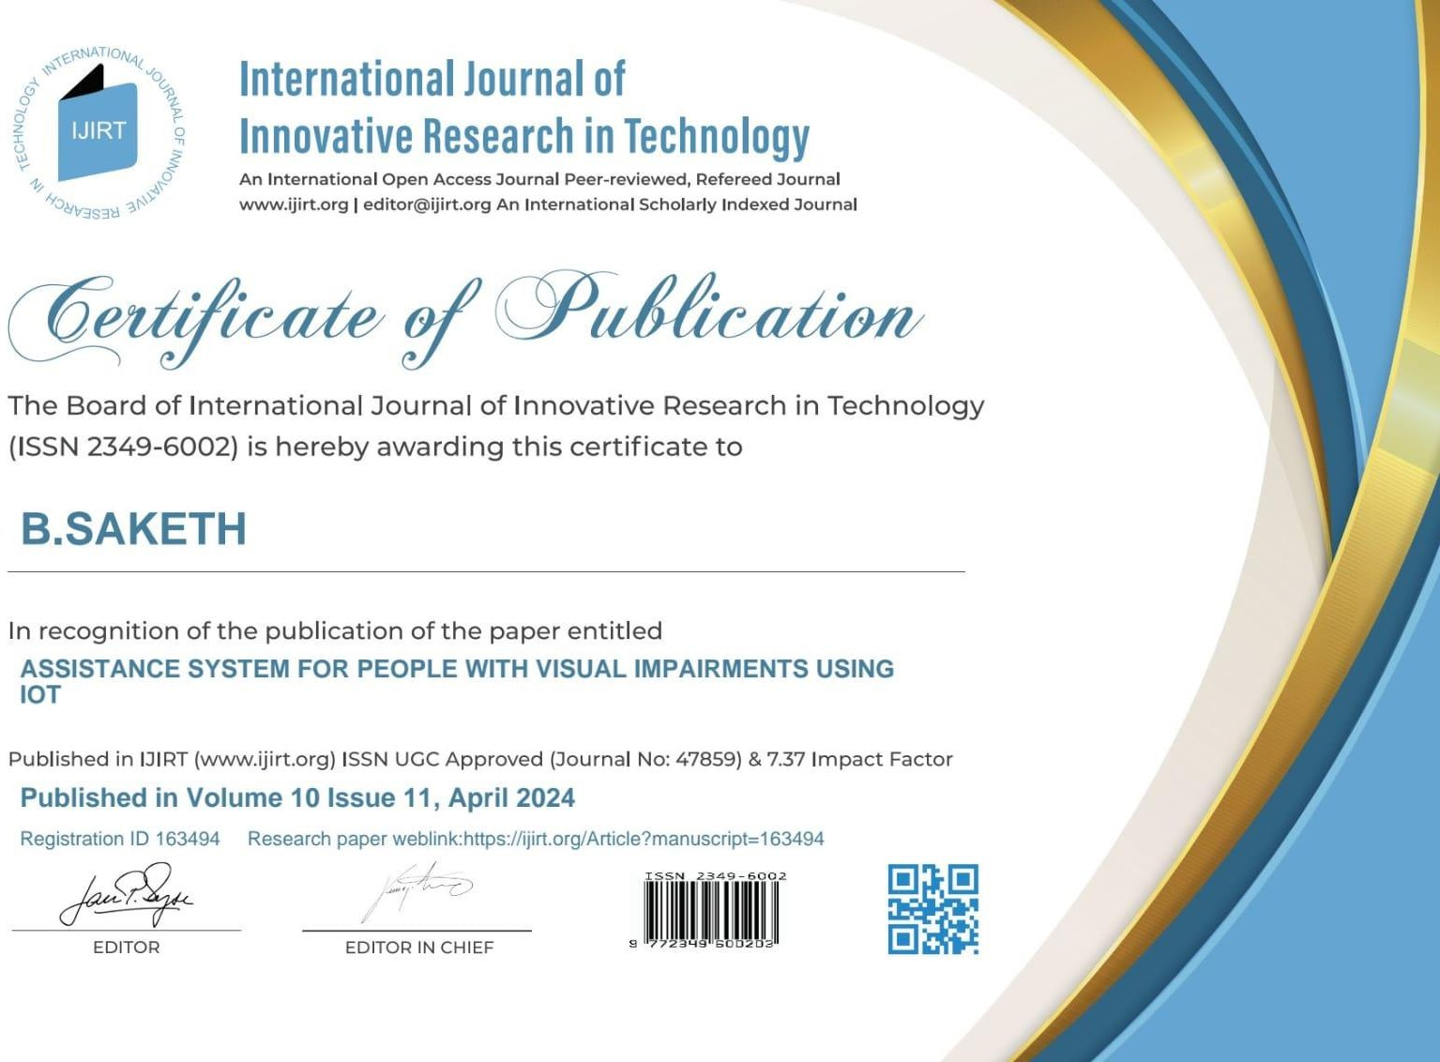

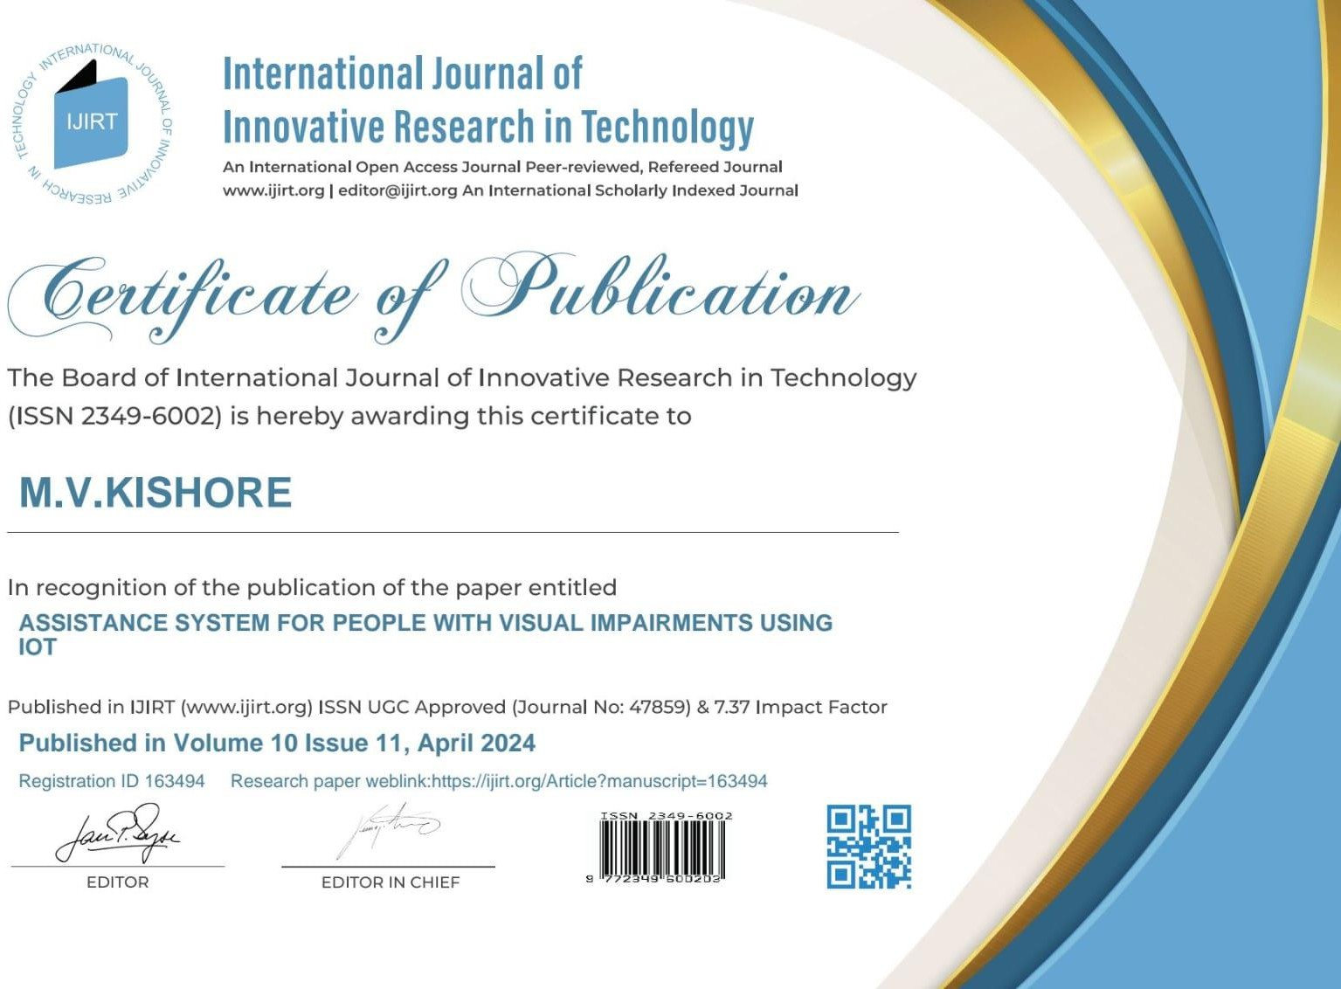

66

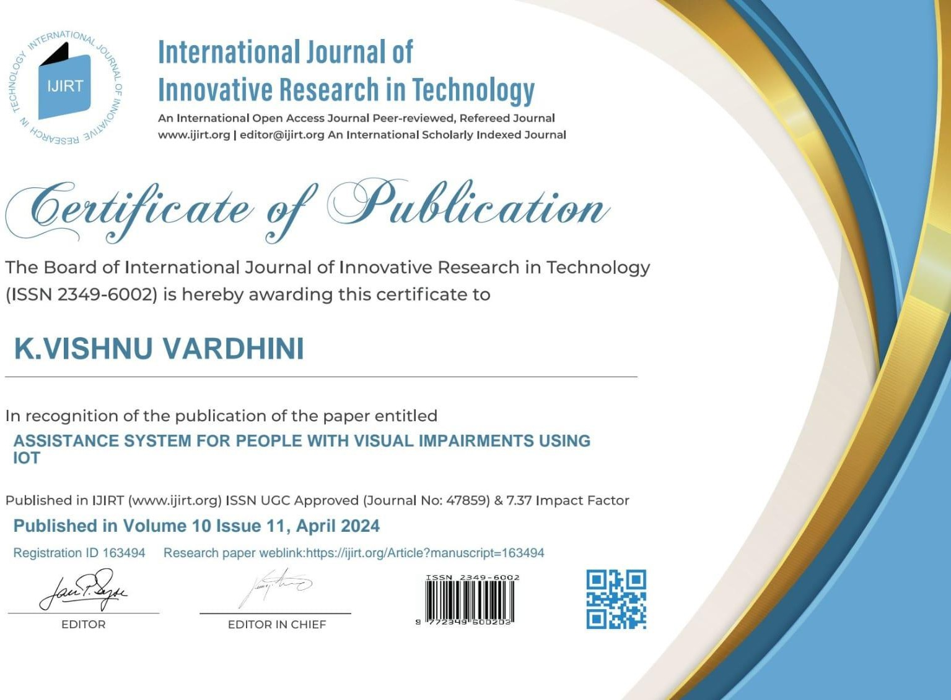

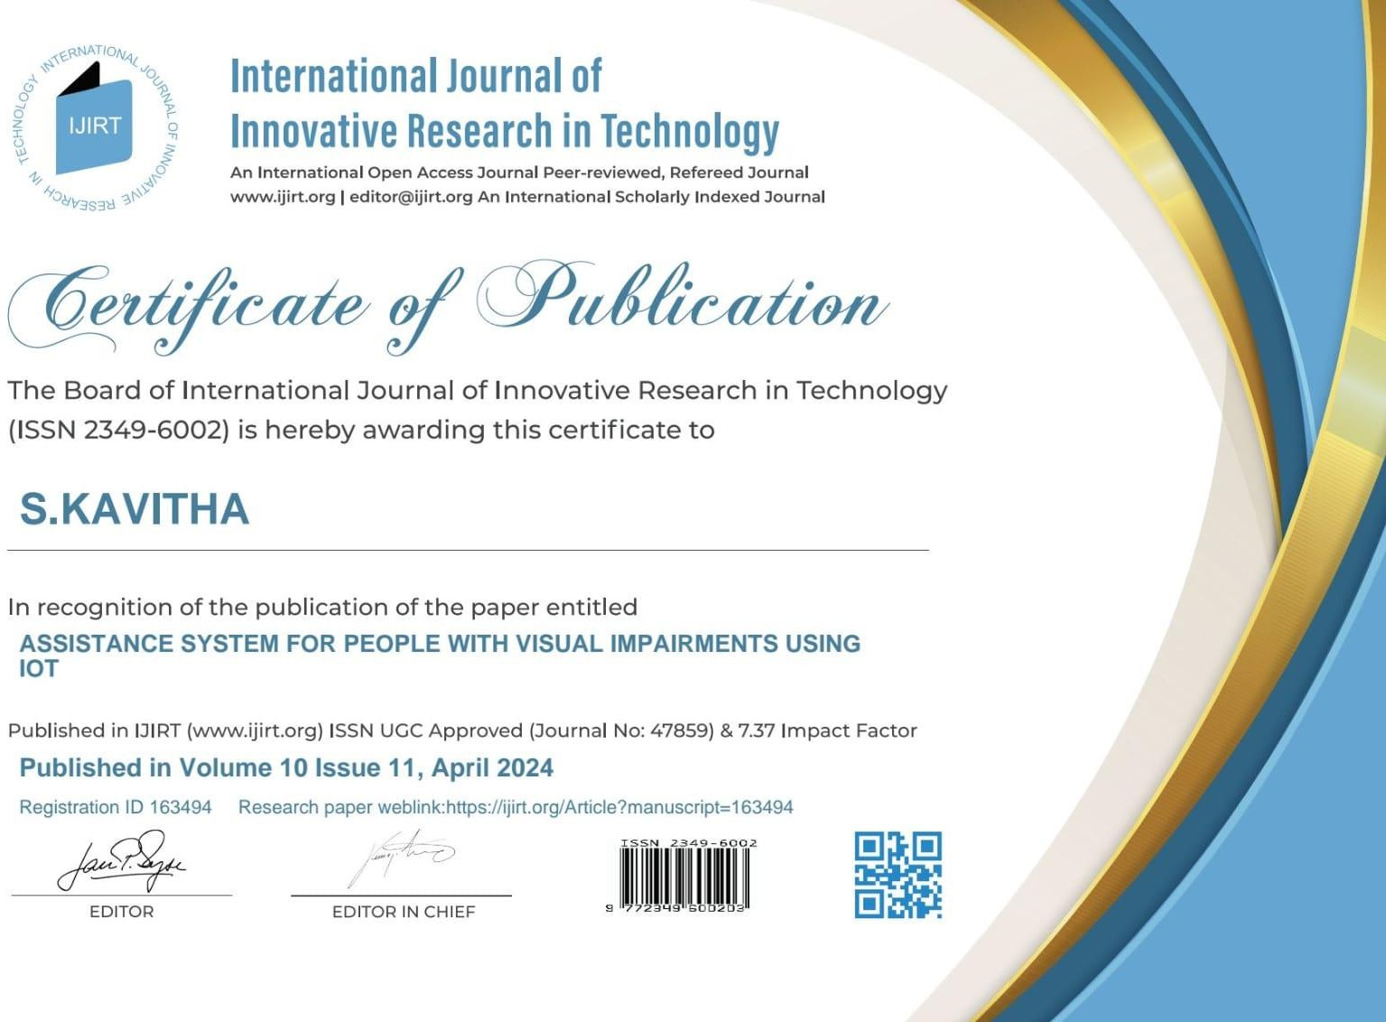

67

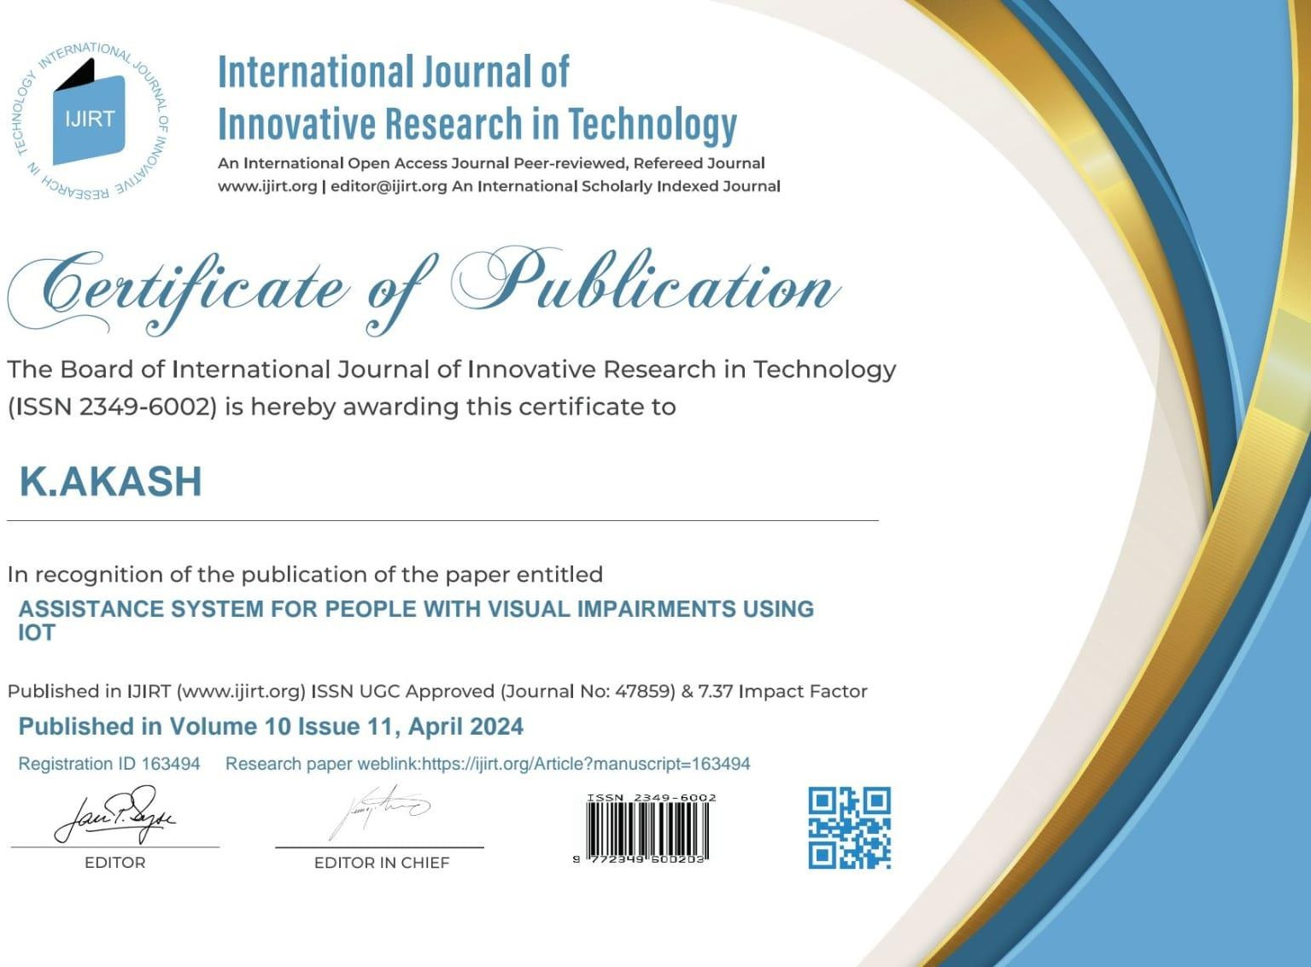

68

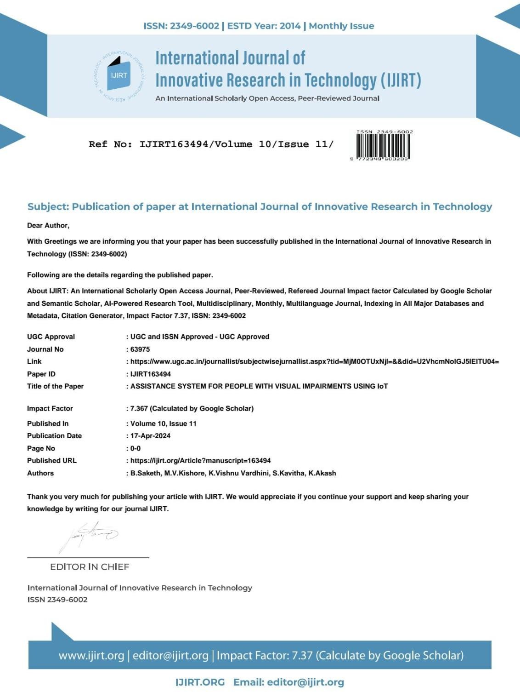

69

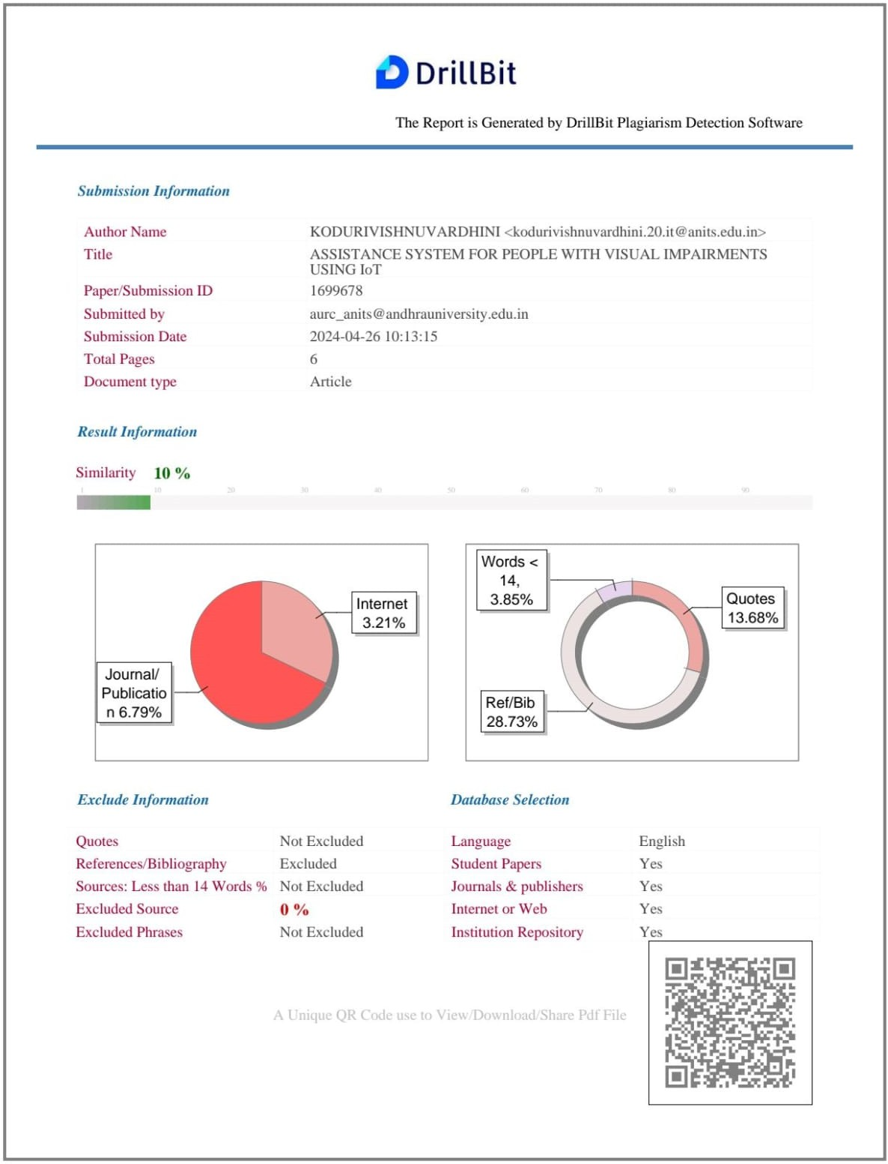

70

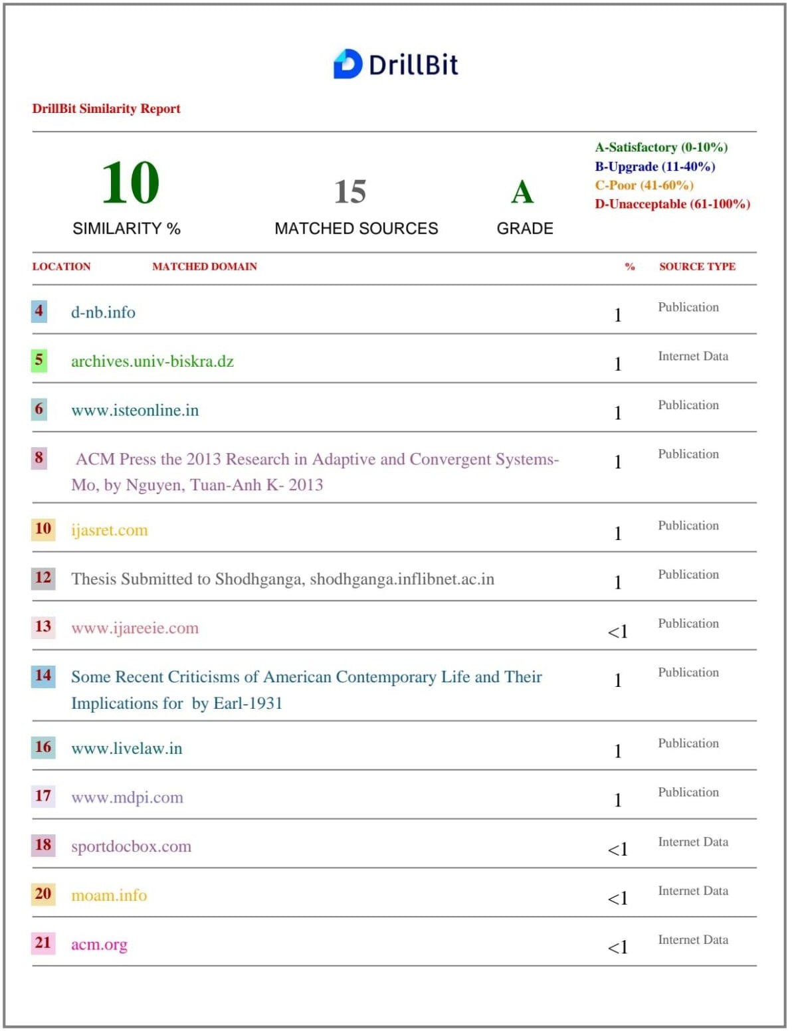

71